附件2

惠州市部分饮用水水源保护区示意图
及拐点坐标

岭下东江饮用水水源保护区示意图
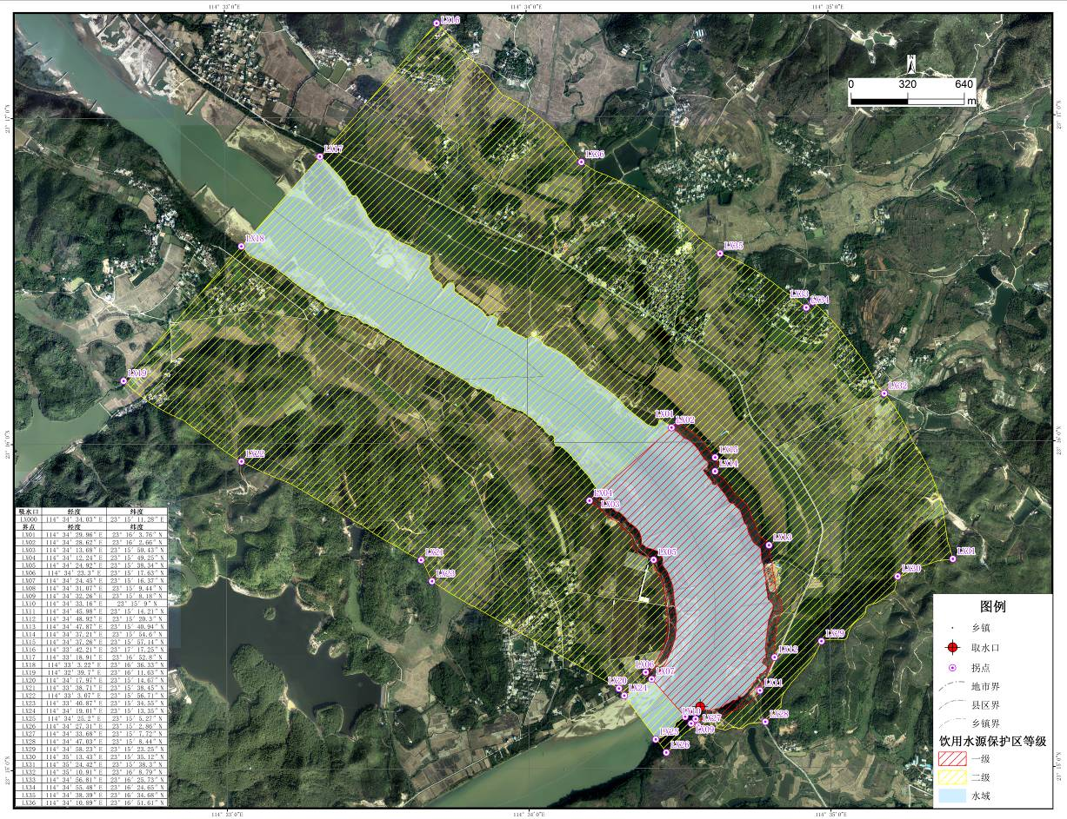

岭下东江饮用水水源保护区边界拐点坐标
序号 | 经度 | 纬度 | 序号 | 经度 | 纬度
LX01 | 114°34′29.96″E | 23°16′3.76″N | LX21 | 114°33′38.71″E | 23°15′38.45″N
LX02 | 114°34′28.62″E | 23°16′2.66″N | LX22 | 114°33′3.07″E | 23°15′56.71″N
LX03 | 114°34′13.68″E | 23°15′50.43″N | LX23 | 114°33′40.87″E | 23°15′34.55″N
LX04 | 114°34′12.24″E | 23°15′49.25″N | LX24 | 114°34′19.01″E | 23°15′13.35″N
LX05 | 114°34′24.92″E | 23°15′38.34″N | LX25 | 114°34′25.2″E | 23°15′5.27″N
LX06 | 114°34′23.3″E | 23°15′17.63″N | LX26 | 114°34′27.31″E | 23°15′2.86″N
LX07 | 114°34′24.45″E | 23°15′16.37″N | LX27 | 114°34′33.68″E | 23°15′7.72″N
LX08 | 114°34′31.07″E | 23°15′9.44″N | LX28 | 114°34′47.03″E | 23°15′8.44″N
LX09 | 114°34′32.26″E | 23°15′8.18″N | LX29 | 114°34′58.23″E | 23°15′23.25″N
LX10 | 114°34′33.16″E | 23°15′9″N | LX30 | 114°35′13.43″E | 23°15′35.12″N
LX11 | 114°34′45.98″E | 23°15′14.21″N | LX31 | 114°35′24.42″E | 23°15′38.3″N
LX12 | 114°34′48.92″E | 23°15′20.3″N | LX32 | 114°35′10.91″E | 23°16′8.79″N
LX13 | 114°34′47.87″E | 23°15′40.94″N | LX33 | 114°34′56.81″E | 23°16′25.73″N
LX14 | 114°34′37.21″E | 23°15′54.6″N | LX34 | 114°34′55.48″E | 23°16′24.65″N
LX15 | 114°34′37.26″E | 23°15′57.14″N | LX35 | 114°34′38.39″E | 23°16′34.68″N
LX16 | 114°33′42.21″E | 23°17′17.25″N | LX36 | 114°34′10.89″E | 23°16′51.61″N
LX17 | 114°33′18.91″E | 23°16′52.8″N
LX18 | 114°33′3.22″E | 23°16′36.33″N
LX19 | 114°32′39.7″E | 23°16′11.63″N
LX20 | 114°34′17.97″E | 23°15′14.67″N
盘沱东江饮用水水源保护区示意图
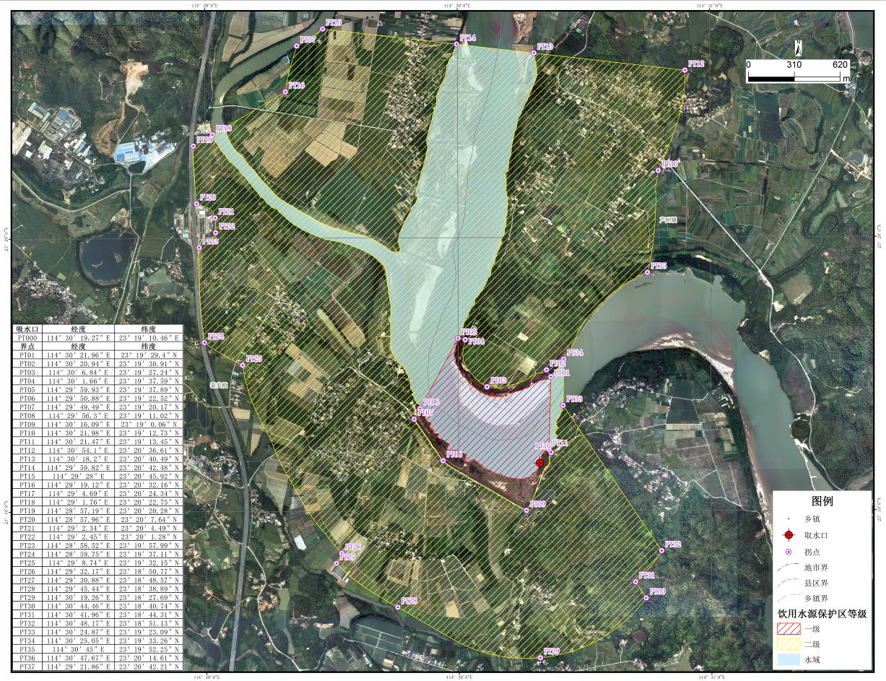

盘沱东江饮用水水源保护区边界拐点坐标
序号 | 经度 | 纬度 | 序号 | 经度 | 纬度
PT01 | 114°30′21.96″E | 23°19′29.4″N | PT21 | 114°29′2.34″E | 23°20′4.49″N
PT02 | 114°30′20.94″E | 23°19′30.91″N | PT22 | 114°29′2.45″E | 23°20′1.28″N
PT03 | 114°30′6.84″E | 23°19′27.24″N | PT23 | 114°28′58.52″E | 23°19′57.99″N
PT04 | 114°30′1.66″E | 23°19′37.59″N | PT24 | 114°28′59.75″E | 23°19′37.11″N
PT05 | 114°29′59.93″E | 23°19′37.89″N | PT25 | 114°29′8.74″E | 23°19′32.15″N
PT06 | 114°29′50.88″E | 23°19′22.52″N | PT26 | 114°29′32.17″E | 23°18′50.77″N
PT07 | 114°29′49.49″E | 23°19′20.17″N | PT27 | 114°29′30.88″E | 23°18′48.57″N
PT08 | 114°29′56.3″E | 23°19′11.02″N | PT28 | 114°29′45.44″E | 23°18′38.89″N
PT09 | 114°30′16.09″E | 23°19′0.06″N | PT29 | 114°30′19.26″E | 23°18′27.69″N
PT10 | 114°30′21.98″E | 23°19′12.73″N | PT30 | 114°30′44.46″E | 23°18′40.74″N
PT11 | 114°30′21.47″E | 23°19′13.45″N | PT31 | 114°30′41.96″E | 23°18′44.31″N
PT12 | 114°30′54.1″E | 23°20′36.61″N | PT32 | 114°30′48.17″E | 23°18′51.13″N
PT13 | 114°30′18.2″E | 23°20′40.49″N | PT33 | 114°30′24.87″E | 23°19′23.09″N
PT14 | 114°29′59.82″E | 23°20′42.48″N | PT34 | 114°30′25.05″E | 23°19′33.26″N
PT15 | 114°29′28″E | 23°20′45.92″N | PT35 | 114°30′45″E | 23°19′52.25″N
PT16 | 114°29′19.12″E | 23°20′32.16″N | PT36 | 114°30′47.67″E | 23°20′14.61″N
PT17 | 114°29′4.69″E | 23°20′24.34″N | PT37 | 114°29′21.86″E | 23°20′42.21″N
PT18 | 114°29′1.76″E | 23°20′22.75″N
PT19 | 114°28′57.19″E | 23°20′20.28″N
PT20 | 114°28′57.96″E | 23°20′7.64″N
下坝水库饮用水水源保护区示意图
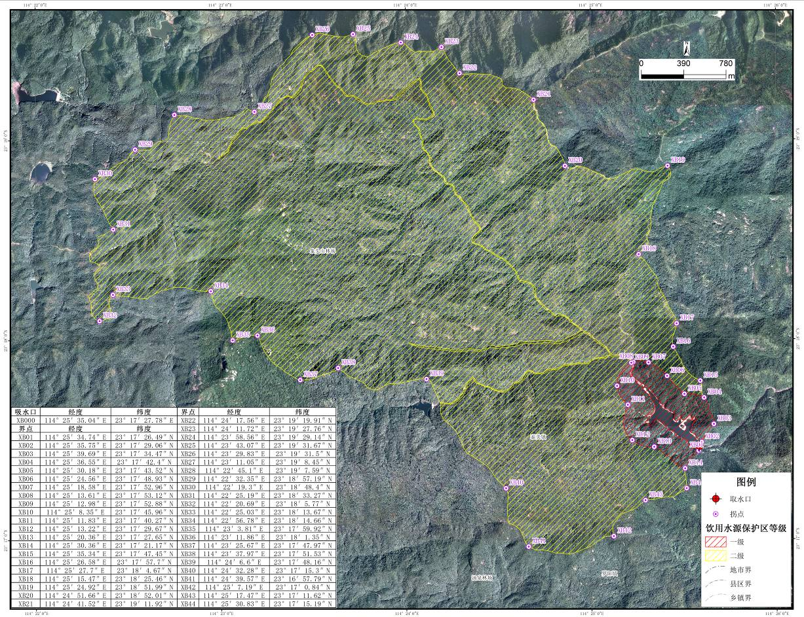

下坝水库饮用水水源保护区边界拐点坐标
序号 | 经度 | 纬度 | 序号 | 经度 | 纬度
XB01 | 114°25′34.74″E | 23°17′26.49″N | XB23 | 114°24′11.72″E | 23°19′27.76″N
XB02 | 114°25′35.75″E | 23°17′29.06″N | XB24 | 114°23′58.56″E | 23°19′29.14″N
XB03 | 114°25′39.69″E | 23°17′34.47″N | XB25 | 114°23′43.07″E | 23°19′31.67″N
XB04 | 114°25′36.55″E | 23°17′42.4″N | XB26 | 114°23′29.83″E | 23°19′31.5″N
XB05 | 114°25′30.18″E | 23°17′43.52″N | XB27 | 114°23′11.05″E | 23°19′8.45″N
XB06 | 114°25′24.56″E | 23°17′48.93″N | XB28 | 114°22′45.1″E | 23°19′7.59″N
XB07 | 114°25′18.58″E | 23°17′52.96″N | XB29 | 114°22′32.35″E | 23°18′57.19″N
XB08 | 114°25′13.61″E | 23°17′53.12″N | XB30 | 114°22′19.3″E | 23°18′48.4″N
XB09 | 114°25′12.98″E | 23°17′52.88″N | XB31 | 114°22′25.19″E | 23°18′33.27″N
XB10 | 114°25′8.35″E | 23°17′45.96″N | XB32 | 114°22′20.69″E | 23°18′5.77″N
XB11 | 114°25′11.83″E | 23°17′40.27″N | XB33 | 114°22′25.03″E | 23°18′13.67″N
XB12 | 114°25′13.22″E | 23°17′29.67″N | XB34 | 114°22′56.78″E | 23°18′14.66″N
XB13 | 114°25′20.36″E | 23°17′27.65″N | XB35 | 114°23′3.81″E | 23°17′59.92″N
XB14 | 114°25′30.36″E | 23°17′21.17″N | XB36 | 114°23′11.86″E | 23°18′1.35″N
XB15 | 114°25′35.34″E | 23°17′47.45″N | XB37 | 114°23′25.67″E | 23°17′47.97″N
XB16 | 114°25′26.58″E | 23°17′57.7″N | XB38 | 114°23′37.97″E | 23°17′51.53″N
XB17 | 114°25′27.7″E | 23°18′4.67″N | XB39 | 114°24′6.6″E | 23°17′48.16″N
XB18 | 114°25′15.47″E | 23°18′25.46″N | XB40 | 114°24′32.28″E | 23°17′15.3″N
XB19 | 114°25′24.92″E | 23°18′51.99″N | XB41 | 114°24′39.57″E | 23°16′57.79″N
XB20 | 114°24′51.66″E | 23°18′52.01″N | XB42 | 114°25′7.19″E | 23°17′0.84″N
XB21 | 114°24′41.52″E | 23°19′11.92″N | XB43 | 114°25′17.47″E | 23°17′11.62″N
XB22 | 114°24′17.56″E | 23°19′19.91″N | XB44 | 114°25′30.83″E | 23°17′15.19″N
黄山洞水库饮用水水源保护区示意图
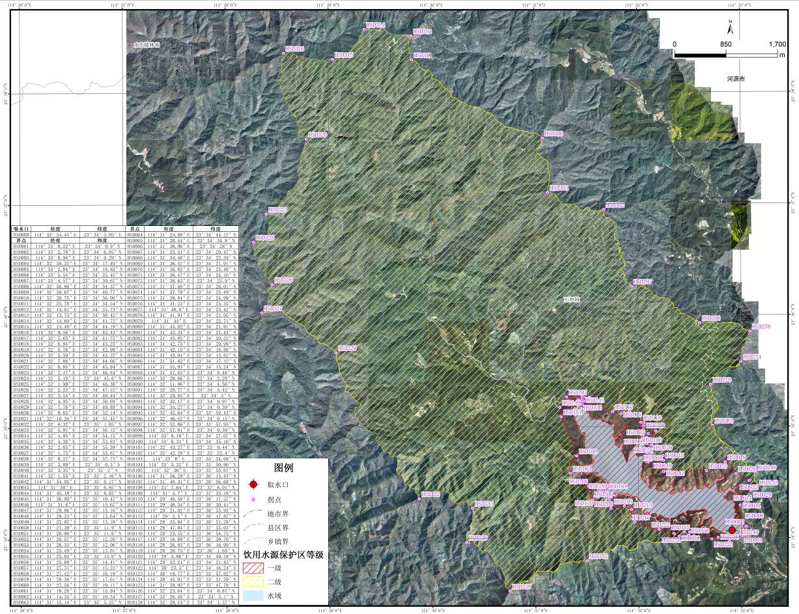

黄山洞水库饮用水水源保护区边界拐点坐标
序号 | 经度 | 纬度 | 序号 | 经度 | 纬度
HSD001 | 114°33′0.22″E | 23°34′0.9″N | HSD023 | 114°32′7.17″E | 23°34′46.84″N
HSD002 | 114°33′2.78″E | 23°34′6.05″N | HSD024 | 114°32′5.18″E | 23°34′45.8″N
HSD003 | 114°33′0.94″E | 23°34′9.29″N | HSD025 | 114°32′1.99″E | 23°34′46.38″N
HSD004 | 114°32′59.37″E | 23°34′17.49″N | HSD026 | 114°32′2.23″E | 23°34′47.15″N
HSD005 | 114°33′2.04″E | 23°34′18.83″N | HSD027 | 114°32′3.54″E | 23°34′48.44″N
HSD006 | 114°33′5.54″E | 23°34′25.45″N | HSD028 | 114°32′4.95″E | 23°34′50.69″N
HSD007 | 114°33′4.57″E | 23°34′30.67″N | HSD029 | 114°32′7.76″E | 23°34′49.89″N
HSD008 | 114°32′56.86″E | 23°34′34.37″N | HSD030 | 114°32′8.05″E | 23°34′52.14″N
HSD009 | 114°32′50.67″E | 23°34′40.77″N | HSD031 | 114°32′10.26″E | 23°34′57.45″N
HSD010 | 114°32′39.75″E | 23°34′36.06″N | HSD032 | 114°32′6.32″E | 23°35′1.05″N
HSD011 | 114°32′25.78″E | 23°34′34.54″N | HSD033 | 114°32′5.87″E | 23°34′56.12″N
HSD012 | 114°32′14.81″E | 23°34′35.73″N | HSD034 | 114°32′4.95″E | 23°34′54.13″N
HSD013 | 114°32′13.73″E | 23°34′38.42″N | HSD035 | 114°32′4.38″E | 23°34′53.83″N
HSD014 | 114°32′14.69″E | 23°34′41.72″N | HSD036 | 114°32′2.85″E | 23°34′55.39″N
HSD015 | 114°32′14.48″E | 23°34′44.19″N | HSD037 | 114°32′1.75″E | 23°34′55.67″N
HSD016 | 114°32′9.56″E | 23°34′42.43″N | HSD038 | 114°32′0.27″E | 23°34′57.73″N
HSD017 | 114°32′7.63″E | 23°34′41.75″N | HSD039 | 114°32′3.09″E | 23°35′0.3″N
HSD018 | 114°32′6.84″E | 23°34′43.23″N | HSD040 | 114°32′3.35″E | 23°35′2″N
HSD019 | 114°32′5.76″E | 23°34′42.98″N | HSD041 | 114°32′1.55″E | 23°35′2.16″N
HSD020 | 114°32′5.59″E | 23°34′43.22″N | HSD042 | 114°31′54.93″E | 23°35′8.17″N
HSD021 | 114°32′7.08″E | 23°34′44.66″N | HSD043 | 114°31′50″E | 23°35′6.85″N
HSD022 | 114°32′8.05″E | 23°34′45.94″N | HSD044 | 114°31′45.18″E | 23°35′8.03″N
HSD045 | 114°31′36.99″E | 23°35′10.47″N | HSD067 | 114°31′33.31″E | 23°34′20.47″N
HSD046 | 114°31′31.6″E | 23°35′15.67″N | HSD068 | 114°31′34.48″E | 23°34′22.39″N
HSD047 | 114°31′29.86″E | 23°35′15.16″N | HSD069 | 114°31′36.52″E | 23°34′21.91″N
HSD048 | 114°31′29.33″E | 23°35′13.64″N | HSD070 | 114°31′36.83″E | 23°34′23.46″N
HSD049 | 114°31′27.92″E | 23°35′13.18″N | HSD071 | 114°31′36.47″E | 23°34′24.16″N
HSD050 | 114°31′27.39″E | 23°35′11.9″N | HSD072 | 114°31′36.63″E | 23°34′25.9″N
HSD051 | 114°31′26.86″E | 23°35′11.8″N | HSD073 | 114°31′37.68″E | 23°34′26.01″N
HSD052 | 114°31′26.57″E | 23°35′12.26″N | HSD074 | 114°31′37.79″E | 23°34′25.49″N
HSD053 | 114°31′26.33″E | 23°35′12.06″N | HSD075 | 114°31′39.84″E | 23°34′24.99″N
HSD054 | 114°31′25.49″E | 23°35′13.01″N | HSD076 | 114°31′41.33″E | 23°34′25.35″N
HSD055 | 114°31′25.03″E | 23°35′13.9″N | HSD077 | 114°31′40.9″E | 23°34′23.42″N
HSD056 | 114°31′25.08″E | 23°35′14.41″N | HSD078 | 114°31′41.91″E | 23°34′22.05″N
HSD057 | 114°31′27.31″E | 23°35′15.23″N | HSD079 | 114°31′44″E | 23°34′22.71″N
HSD058 | 114°31′27.42″E | 23°35′16.19″N | HSD080 | 114°31′44.02″E | 23°34′21.91″N
HSD059 | 114°31′28.38″E | 23°35′17.61″N | HSD081 | 114°31′43.34″E | 23°34′21.43″N
HSD060 | 114°31′27.56″E | 23°35′19.11″N | HSD082 | 114°31′43.05″E | 23°34′20.52″N
HSD061 | 114°31′18.26″E | 23°35′15.94″N | HSD083 | 114°31′42.75″E | 23°34′20.99″N
HSD062 | 114°31′14.35″E | 23°35′10.34″N | HSD084 | 114°31′42.15″E | 23°34′18.88″N
HSD063 | 114°31′15.14″E | 23°35′5.25″N | HSD085 | 114°31′43.94″E | 23°34′15.82″N
HSD064 | 114°31′24.09″E | 23°34′44.17″N | HSD086 | 114°31′51.82″E | 23°34′17.12″N
HSD065 | 114°31′20.44″E | 23°34′34.8″N | HSD087 | 114°31′55.93″E | 23°34′15.24″N
HSD066 | 114°31′30.96″E | 23°34′28″N | HSD088 | 114°31′57.83″E | 23°34′8.48″N

序号 | 经度 | 纬度 | 序号 | 经度 | 纬度
HSD089 | 114°32′20.66″E | 23°34′2.29″N | HSD111 | 114°29′48.34″E | 23°38′30.41″N
HSD090 | 114°32′11.96″E | 23°34′4.56″N | HSD112 | 114°29′21.02″E | 23°38′33.95″N
HSD091 | 114°32′28.77″E | 23°34′5.42″N | HSD113 | 114°29′2.5″E | 23°38′17.87″N
HSD092 | 114°32′29.83″E | 23°34′3″N | HSD114 | 114°28′33.84″E | 23°38′21.28″N
HSD093 | 114°32′32.17″E | 23°34′0.97″N | HSD115 | 114°28′47.04″E | 23°37′35.03″N
HSD094 | 114°32′34.27″E | 23°34′0.39″N | HSD116 | 114°28′23.55″E | 23°36′54.75″N
HSD095 | 114°32′42.64″E | 23°33′59.43″N | HSD117 | 114°28′16.08″E | 23°36′39.76″N
HSD096 | 114°32′46.42″E | 23°34′0.15″N | HSD118 | 114°28′26.83″E | 23°36′16.99″N
HSD097 | 114°32′52.86″E | 23°33′57.95″N | HSD119 | 114°28′20.75″E | 23°36′1.69″N
HSD098 | 114°32′57.81″E | 23°34′0.39″N | HSD120 | 114°29′3.86″E | 23°35′40.18″N
HSD099 | 114°33′9.18″E | 23°34′27.07″N | HSD121 | 114°29′52.21″E | 23°34′21.45″N
HSD100 | 114°33′8.31″E | 23°34′35.16″N | HSD122 | 114°30′23.3″E | 23°34′16.24″N
HSD101 | 114°32′43.27″E | 23°35′0.44″N | HSD123 | 114°30′19.77″E | 23°33′57.82″N
HSD102 | 114°32′42.29″E | 23°35′22.4″N | HSD124 | 114°30′45.01″E | 23°33′31.59″N
HSD103 | 114°33′0″E | 23°35′34.69″N | HSD125 | 114°31′29.92″E | 23°33′47.78″N
HSD104 | 114°33′5.32″E | 23°35′50.96″N | HSD126 | 114°32′23.64″E | 23°34′0.87″N
HSD105 | 114°32′36″E | 23°35′55.67″N | HSD127 | 114°32′26.48″E | 23°34′3.1″N
HSD106 | 114°31′56.29″E | 23°36′15.43″N | HSD128 | 114°32′29.13″E | 23°34′1.37″N
HSD107 | 114°31′40.31″E | 23°36′56.68″N
HSD108 | 114°31′7.64″E | 23°37′6.01″N
HSD109 | 114°31′4.7″E | 23°37′35.19″N
HSD110 | 114°29′48.58″E | 23°38′17.57″N

显岗水库饮用水水源保护区示意图
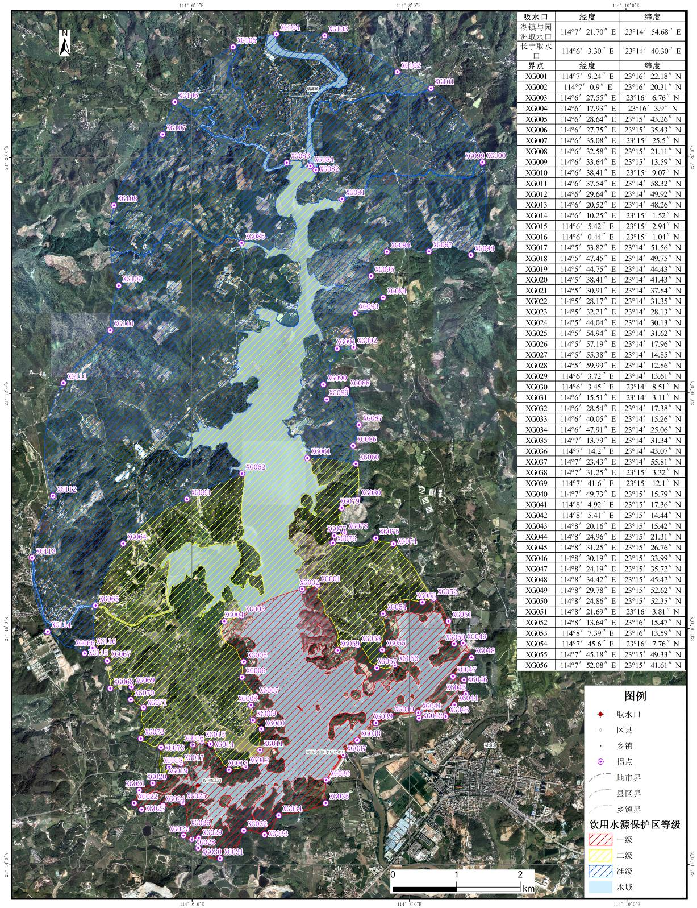

显岗水库饮用水水源保护区边界拐点坐标
序号 | 经度 | 纬度 | 序号 | 经度 | 纬度
XG001 | 114°7′9.24″E | 23°16′22.18″N | XG021 | 114°5′30.91″E | 23°14′37.84″N
XG002 | 114°7′0.9″E | 23°16′20.31″N | XG022 | 114°5′28.17″E | 23°14′31.35″N
XG003 | 114°6′27.55″E | 23°16′6.76″N | XG023 | 114°5′32.21″E | 23°14′28.13″N
XG004 | 114°6′17.93″E | 23°16′3.9″N | XG024 | 114°5′44.04″E | 23°14′30.13″N
XG005 | 114°6′28.64″E | 23°15′43.26″N | XG025 | 114°5′54.94″E | 23°14′31.62″N
XG006 | 114°6′27.75″E | 23°15′35.43″N | XG026 | 114°5′57.19″E | 23°14′17.96″N
XG007 | 114°6′35.08″E | 23°15′25.5″N | XG027 | 114°5′55.38″E | 23°14′14.85″N
XG008 | 114°6′32.58″E | 23°15′21.11″N | XG028 | 114°5′59.99″E | 23°14′12.86″N
XG009 | 114°6′33.64″E | 23°15′13.59″N | XG029 | 114°6′3.72″E | 23°14′13.61″N
XG010 | 114°6′38.41″E | 23°15′9.07″N | XG030 | 114°6′3.45″E | 23°14′8.51″N
XG011 | 114°6′37.54″E | 23°14′58.32″N | XG031 | 114°6′15.51″E | 23°14′3.11″N
XG012 | 114°6′29.64″E | 23°14′49.92″N | XG032 | 114°6′28.54″E | 23°14′17.38″N
XG013 | 114°6′20.52″E | 23°14′48.26″N | XG033 | 114°6′40.05″E | 23°14′15.26″N
XG014 | 114°6′10.25″E | 23°15′1.52″N | XG034 | 114°6′47.91″E | 23°14′25.06″N
XG015 | 114°6′5.42″E | 23°15′2.94″N | XG035 | 114°7′13.79″E | 23°14′31.34″N
XG016 | 114°6′0.44″E | 23°15′1.04″N | XG036 | 114°7′14.2″E | 23°14′43.07″N
XG017 | 114°5′53.82″E | 23°14′51.56″N | XG037 | 114°7′23.43″E | 23°14′55.81″N
XG018 | 114°5′47.45″E | 23°14′49.75″N | XG038 | 114°7′31.25″E | 23°15′3.32″N
XG019 | 114°5′44.75″E | 23°14′44.43″N | XG039 | 114°7′41.6″E | 23°15′12.1″N
XG020 | 114°5′38.41″E | 23°14′41.43″N | XG040 | 114°7′49.73″E | 23°15′15.79″N
XG041 | 114°8′4.92″E | 23°15′17.36″N | XG062 | 114°6′27.77″E | 23°17′19.09″N
XG042 | 114°8′5.41″E | 23°15′14.44″N | XG063 | 114°5′57.35″E | 23°17′6.07″N
XG043 | 114°8′20.16″E | 23°15′15.42″N | XG064 | 114°5′22.13″E | 23°16′43.51″N
XG044 | 114°8′24.96″E | 23°15′21.31″N | XG065 | 114°5′6.89″E | 23°16′12″N
XG045 | 114°8′31.25″E | 23°15′26.76″N | XG066 | 114°5′6.39″E | 23°15′49.51″N
XG046 | 114°8′30.19″E | 23°15′33.99″N | XG067 | 114°5′13.34″E | 23°15′43.85″N
XG047 | 114°8′24.19″E | 23°15′35.72″N | XG068 | 114°5′14.96″E | 23°15′29.76″N
XG048 | 114°8′34.42″E | 23°15′45.42″N | XG069 | 114°5′26.63″E | 23°15′30.57″N
XG049 | 114°8′29.78″E | 23°15′52.62″N | XG070 | 114°5′26.26″E | 23°15′24.09″N
XG050 | 114°8′24.86″E | 23°15′52.35″N | XG071 | 114°5′33.23″E | 23°15′20.03″N
XG051 | 114°8′21.69″E | 23°16′3.81″N | XG072 | 114°5′31.82″E | 23°15′4.2″N
XG052 | 114°8′13.64″E | 23°16′15.47″N | XG073 | 114°5′42.99″E | 23°14′59.79″N
XG053 | 114°8′7.39″E | 23°16′13.59″N | XG074 | 114°7′51.37″E | 23°16′43.26″N
XG054 | 114°7′45.6″E | 23°16′7.76″N | XG075 | 114°7′41.61″E | 23°16′46.15″N
XG055 | 114°7′45.18″E | 23°15′49.33″N | XG076 | 114°7′17.97″E | 23°16′43.83″N
XG056 | 114°7′52.08″E | 23°15′41.61″N | XG077 | 114°7′18.69″E | 23°16′47.49″N
XG057 | 114°7′42.11″E | 23°15′40.14″N | XG078 | 114°7′24.34″E | 23°16′48.99″N
XG058 | 114°7′31.52″E | 23°15′51.65″N | XG079 | 114°7′22.73″E | 23°17′1.58″N
XG059 | 114°7′20.48″E | 23°15′49.06″N | XG080 | 114°7′31.56″E | 23°17′5.91″N
XG060 | 114°7′30.63″E | 23°17′24.07″N | XG081 | 114°7′23.03″E | 23°19′38.77″N
XG061 | 114°7′3.83″E | 23°17′26.98″N | XG082 | 114°7′8.6″E | 23°19′53.59″N
XG083 | 114°6′52.68″E | 23°19′57.33″N | XG100 | 114°8′40.72″E | 23°19′57.45″N
XG084 | 114°7′5.7″E | 23°19′55.64″N | XG101 | 114°8′12.32″E | 23°20′35.08″N
XG085 | 114°6′27.62″E | 23°19′16.47″N | XG102 | 114°7′53.74″E | 23°20′43.44″N
XG086 | 114°7′29.13″E | 23°17′33.15″N | XG103 | 114°7′13.67″E | 23°21′2.01″N
XG087 | 114°7′32.39″E | 23°17′43.79″N | XG104 | 114°6′46.94″E | 23°21′2.77″N
XG088 | 114°7′25.42″E | 23°18′1.75″N | XG105 | 114°6′23.02″E | 23°20′56.26″N
XG089 | 114°7′14.58″E | 23°17′56.84″N | XG106 | 114°5′50.78″E | 23°20′28.25″N
XG090 | 114°7′12.8″E | 23°18′4.34″N | XG107 | 114°5′44.05″E | 23°20′11.71″N
XG091 | 114°7′20.36″E | 23°18′22.68″N | XG108 | 114°5′17.17″E | 23°19′35.72″N
XG092 | 114°7′29.52″E | 23°18′23.4″N | XG109 | 114°5′19.79″E | 23°18′54.79″N
XG093 | 114°7′30.35″E | 23°18′40.67″N | XG110 | 114°5′15.1″E | 23°18′32.03″N
XG094 | 114°7′45.85″E | 23°18′48.61″N | XG111 | 114°4′49.22″E | 23°18′5.25″N
XG095 | 114°7′39.1″E | 23°18′59.6″N | XG112 | 114°4′43.38″E | 23°17′7.81″N
XG096 | 114°7′47.95″E | 23°19′11.94″N | XG113 | 114°4′31.87″E | 23°16′36.27″N
XG097 | 114°8′11.17″E | 23°19′12.12″N | XG114 | 114°4′40.41″E | 23°15′58.73″N
XG098 | 114°8′34.28″E | 23°19′10.18″N | XG115 | 114°5′0.78″E | 23°15′47.62″N
XG099 | 114°8′40.77″E | 23°19′57.24″N | XG116 | 114°5′5.2″E | 23°15′50.41″N

